**MEDIA RELEASE - MARCH 2023**

**Spandex, synths and stadium rock: Back to the ‘80s with Art & Sol**

Saturday, 3 June (Museum Open Day) – Monday 28 August 2023 *Free entry on Open Day*

*The Musical Museum, 399 High St, Brentford, TW8 0DU*

*Open: Friday, Saturday and Sunday 10am-4pm.*

Exhibition entry included with MM ticket 5-16 £5, Adults £12, Reduced £10

50% discount on entry to residents of the London Borough of Hounslow – more details on [www.musicalmuseum.co.uk](http://www.musicalmuseum.co.uk)

**The Musical Museum and ‘Art & Sol’ are teaming up this summer to stage an exhibition of iconic ‘80s rock and pop musicians - photographed live in concertand reinterpreted through digital portraiture.**

West London was home to many major rock and pop artists who significantly influenced the music, fashion and experiences of the ‘80s. This exhibition provides photographs of live performances at the height of these artists careers, while providing background information on their West London connections and why they had such an effect on the ‘80s.

Art & Sol unites Getty rock photographer Sol N’Jie, who photographed iconic rock and pop performers in concert throughout the ‘80s and Stella Tooth, resident artist of the Half Moon Putney, which has been playing live music since 1963.

Sol says, *“The ‘80s saw a diversity of music genres driven in part by the significant advancements in music technology, such as synthesizers and digital recording techniques, which allowed for new sounds and production methods. The visual aspect of music became just as important, with many musicians creating stunning videos that became cultural phenomena significantly impacting fashion and popular culture. The decade was also a time of political and social change with many musicians commenting on social justice, poverty, and environmental concerns. I was lucky enough to capture some photos that reflected this time.”*

During the ‘80s Solomon (Sol) N’Jie was responsible for the crowd safety management of spectators at large London venues where the world’s leading artists and bands performed. During some of the concerts he used a 35mm camera to capture rare and unseen images from unique vantage points of pop stars that had become global phenomena.

Stella, a trained portrait artist who, for the past six years, has been exploring her practice in the legendary music venue the Half Moon Putney, and Getty Rock photographer Sol decided to produce this side-by-side exhibition to allow the viewer to understand and appreciate what happens when an iconic photo is seen through the lens of an artist’s eye.

Stella says, *“At the Half Moon Putney I’ve portrayed, in traditional media, The Animals, The Kinks and The Pretty Things among others – musicians who once participated in, or were influenced by, the ‘60s British R&B scene generated by The Ealing Club. Being too young to see other sixties bands live at start of their careers, I jumped at the chance to interpret Sol’s ‘80s photos of image-conscious music icons like Adam Ant, David Bowie and Freddie Mercury, to name but a few, at the height of their fame and in a new medium taken up in lockdown - digital painting.”*

Noeleen O’Gorman, Audience Development Manager at The Musical Museum, said,

*“We are delighted to welcome ‘Art & Sol’ to exhibit alongside items from our collection at the Museum. These stunning concert photos and inspired art capture the zeitgeist of the 1980s in West London. The connections to the local area are astounding and something we think will be of great interest to our local residents and music ‘aficionados’ alike.“*

Stella and Sol met in a ‘pop up’ in Ealing where Sol was exhibiting some of the 600 photos, he had taken of ‘80s rockers. The collaboration unites ‘old’ and ‘new technology’ with Sol’s photographs originally taken on an analogue 35mm camera and Stella’s artworks created on an Apple iPad pro using the Procreate app.

Stella Tooth, an ex-print journalist and BBC/Sky News PR, retrained as a portrait artist at The Heatherley School of Fine Art in 2010 and has her home studio in Ealing. Storytelling in words and picture is part of her portrait and performer art. Now, inspired by Sol’s iconic rock photos, she uses colour symbolism and her traditional oil painting skills to create digital portraits with the pressure-sensitive ipencil.

https://stellatooth.co.uk www.iconicrockphotos.net

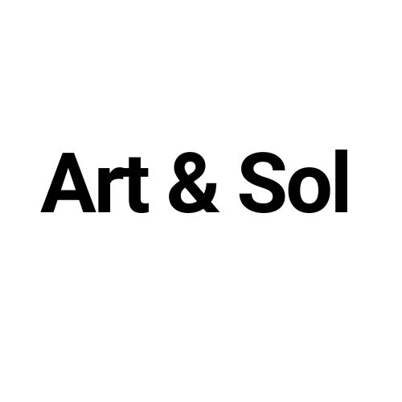

**NOTES TO EDITORS**

**Media call for photographers/journalists & Private View: Wednesday 31 May at 6.00-7.30pm**

**Photos available on request:**

* Sol N’Jie and Stella Tooth outside The Musical Museum
* Canvy room view of Sol N’Jie’s photos and Stella Tooth’s digital paintings side by side
* Noeleen O’Gorman Audience Development Manager The Musical Museum with Stella and Sol

**For further information:** Noeleen O’Gorman [noeleen@musicalmuseum.co.uk](mailto:noeleen@musicalmuseum.co.uk) 020 8560 8108